**Carro con ultrasonido y display**

1. Funcionamiento

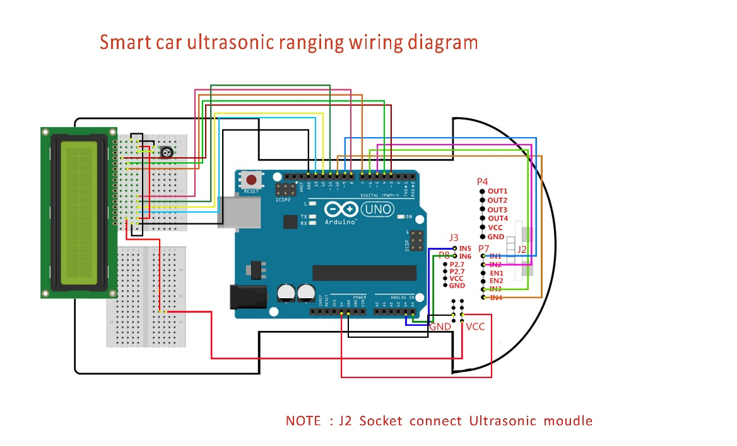

1. Código

#include <LiquidCrystal.h>

LiquidCrystal lcd(3,4,7,8,11,12,13);

int Left_motor_back=9; //(IN1)

int Left_motor_go=5; //(IN2)

int Right_motor_go=6; //(IN3)

int Right_motor_back=10; //(IN4)

int Trig =A4; // Trig(P2.1)IN5

int Echo = A5; // Echo(P2.0)IN6

int Distance = 0;

void setup()

{

Serial.begin(9600);

pinMode(Echo, INPUT);

pinMode(Trig, OUTPUT);

lcd.begin(16,2);

pinMode(Left_motor_go,OUTPUT);

pinMode(Left_motor_back,OUTPUT);

pinMode(Right_motor_go,OUTPUT);

pinMode(Right_motor_back,OUTPUT);

}

void medir_distancia()

{

digitalWrite(Trig, LOW);

delayMicroseconds(2);

digitalWrite(Trig, HIGH);

delayMicroseconds(10);

digitalWrite(Trig, LOW);

float Fdistance = pulseIn(Echo, HIGH);

Fdistance= Fdistance/58;

Serial.print("Distancia:");

Serial.println(Fdistance);

Distance = Fdistance;

}

void loop()

{

run();

medir_distancia();

if((2<Distance)&(Distance<400))

{

lcd.home();

lcd.print(" Distancia: ");

lcd.setCursor(6,2);

lcd.print(Distance);

lcd.print("cm");

}

else

{

lcd.home();

lcd.print("!!!Fuera de rango");

}

delay(250);

lcd.clear();

}

void run()

{

digitalWrite(Right_motor_go,HIGH);

digitalWrite(Right_motor_back,LOW);

analogWrite(Right_motor_go,150);

analogWrite(Right_motor_back,0);

digitalWrite(Left_motor_go,HIGH);

digitalWrite(Left_motor_back,LOW);

analogWrite(Left_motor_go,150);

analogWrite(Left_motor_back,0);

}

void brake(int time)

{

digitalWrite(Right_motor_go,LOW);

digitalWrite(Right_motor_back,LOW);

digitalWrite(Left_motor_go,LOW);

digitalWrite(Left_motor_back,LOW);

delay(time * 100);

}

void left()

{

digitalWrite(Right_motor_go,HIGH);

digitalWrite(Right_motor_back,LOW);

analogWrite(Right_motor_go,175);

analogWrite(Right_motor_back,0);

digitalWrite(Left_motor_go,LOW);

digitalWrite(Left_motor_back,LOW);

analogWrite(Left_motor_go,0);

analogWrite(Left_motor_back,0);

}

void spin_left(int time)

{

digitalWrite(Right_motor_go,HIGH);

digitalWrite(Right_motor_back,LOW);

analogWrite(Right_motor_go,250);

analogWrite(Right_motor_back,0);

digitalWrite(Left_motor_go,LOW);

digitalWrite(Left_motor_back,HIGH);

analogWrite(Left_motor_go,0);

analogWrite(Left_motor_back,100);

delay(time * 100);

}

void right()

{

digitalWrite(Right_motor_go,LOW);

digitalWrite(Right_motor_back,LOW);

analogWrite(Right_motor_go,0);

analogWrite(Right_motor_back,0);

digitalWrite(Left_motor_go,HIGH);

digitalWrite(Left_motor_back,LOW);

analogWrite(Left_motor_go,175);

analogWrite(Left_motor_back,0);

}

void spin_right(int time)

{

digitalWrite(Right_motor_go,LOW);

digitalWrite(Right_motor_back,HIGH);

analogWrite(Right_motor_go,0);

analogWrite(Right_motor_back,100);

digitalWrite(Left_motor_go,HIGH);

digitalWrite(Left_motor_back,LOW);

analogWrite(Left_motor_go,100);

analogWrite(Left_motor_back,0);

delay(time * 100);

}

void back(int time)

{

digitalWrite(Right_motor_go,LOW);

digitalWrite(Right_motor_back,HIGH);

analogWrite(Right_motor_go,0);

analogWrite(Right_motor_back,100);

digitalWrite(Left_motor_go,LOW);

digitalWrite(Left_motor_back,HIGH);

analogWrite(Left_motor_go,0);

analogWrite(Left_motor_back,150);

delay(time * 100);

}